NH 9v9 Winter League
NH Soccer Association & NH SportsDome

League Overview
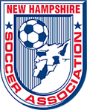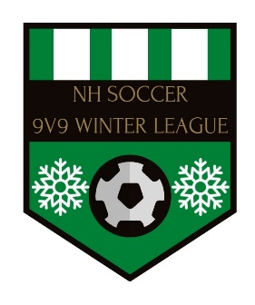
We are pleased to announce that the New Hampshire Soccer Association has partnered with NH SportsDome to provide a competitive winter soccer option for our member clubs. The purpose of the league is to provide a safe environment to focus on development and competitive play for our coaches, players and referees.
CLICK HERE TO REGISTER TODAY!
There are limited spots available. Any member team can register to be in this new league. However, preference on acceptance into the league will be based on the team (and their represented club) meeting the following league standards:
Your clubs have a…….
- Director of Coaching or Equivalent
- Coach/player development policy/practices
- Coaches are USSF (grassroots or otherwise) certified (equivalent licensures accepted)
- Communicated and implemented Parents Code of Conduct policy
- Communicated and implemented Player Code of Conduct policy
- DE&I Policy
…or you are actively working towards accomplishing these things above.
Additionally, it is mandatory that all coaches and bench personnel have...
- Safe sport and risk management certification
Location:
- NH SportsDome, 11 Benton Road, Hooksett, NH 03106
- Website: https://nhsportsdome.com/

Details:
- U11 thru U19 divisions will be offered (boys and girls). Age groups may be combined if necessary
- All games will be played 9v9 (8 field players and a goalkeeper)
- All games will be two (2), thirty (30) minute halves
- Ample warm up time will be provided for teams before games
- Games will be played primarily on weekends (some Friday night games will be played)
- Session 1: Friday, November 5th to Sunday December 19th (one game per weekend, seven total games)
- Session 2: Friday, January 7th to Sunday February 20th (one game per weekend, seven total games)
- Rosters may be up to 22 players; 18 can dress for games
Cost:
- $1549 per session (18 player roster is only $86 per player!)
- Includes 7 games, all referee fees, access to state-of-the-art film footage & analytics, and more.
- Ask about the Live stream membership through Live Barn
  - starts at $18.95 per spectator

REGISTER HERE!
Additional Benefits:
- A professional environment dedicated to the development of the player, the coach and the referee
- All games can be accessed through Live Barn streaming services
- Coach and player access to VEO game film and analytics
- USSF Referees, assignors and mentors
- Christmas and New Year’s off – enjoy time with your families!

Registration:
- Registration for all ages opens on October 1st. CLICK HERE TO REGISTER TODAY!
- Register before October 20th and receive one FREE VEO game film ($100 value)
- Registrations will close on October 28th.
- Upon being accepted into the league, teams will be invoiced on 10/21 (early registrations) and 10/28
- Space is limited, so register today.
- Direct Registration Link: https://system.gotsport.com/event_regs/74c1984bea

Look for updates on the New Hampshire Soccer Association website, including league policies, calendar of events, details on divisions, accepted teams lists, and more!

All questions can be forwarded to the Director of Operations, Ryan Joy, at director@nhsoccerleague.com

