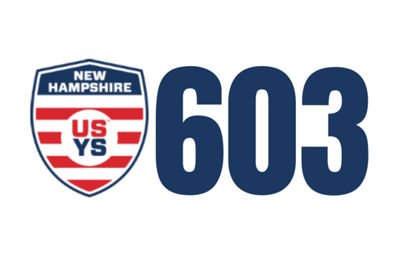
Hello NH ODP Family!
It was great to see so many familiar faces at last week's trainings!
We go again tonight at separate facilities. As always, the full schedule can be found here: https://soccernh.com/odp/schedules-events/
That schedule has the details for the entire Spring and a link to the current Albany schedule (subject to change by region decisions). We expect the Regional event schedule to be published around May 1st.
Tonight's schedule is as follows:
Goffstown: 5:30-7:00 - Boys U12, U13, U14
Goffstown: 7:00-8:30 - Boys U15, U16, U17
Hooksett: 5:30-7:00 - Girls U12, U13, U14
Hooksett: 7:00-8:30 - Girls U15, U16, U17
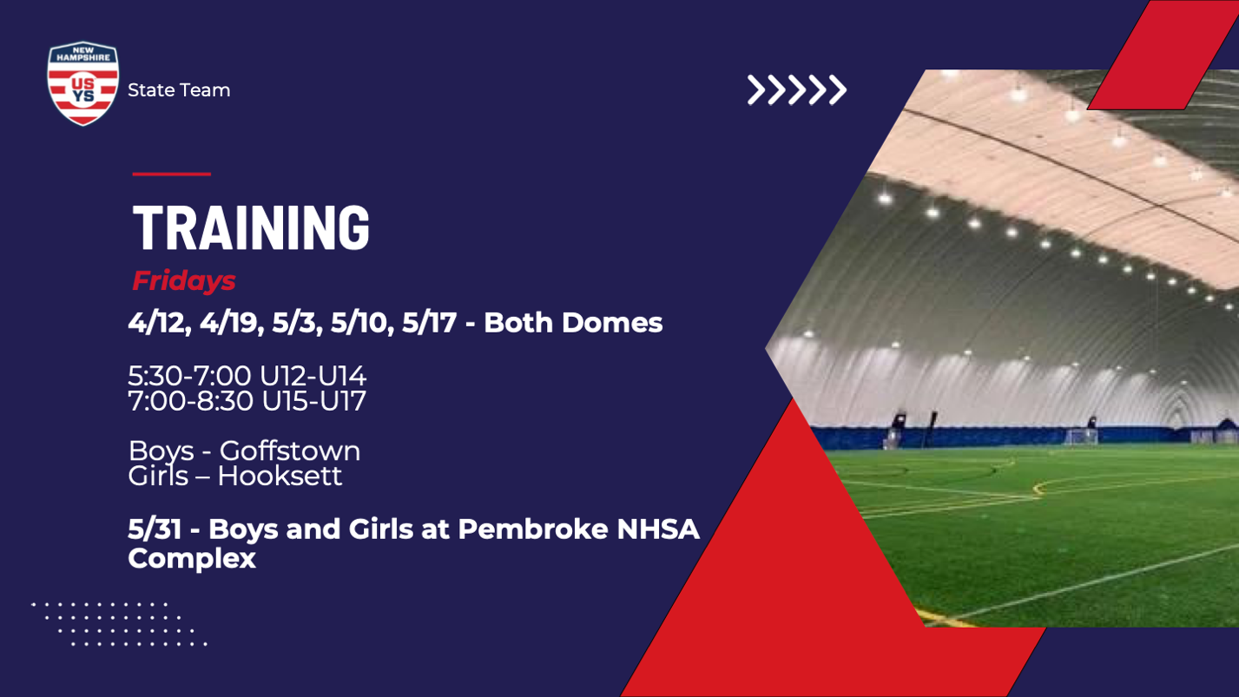
Tonight we are excited to welcome our new Goalkeeper Director take the field. Phil Tuttle is a coach with Southern New Hampshire University (SNHU), was a captain for the University of Notre Dame, was drafted into the MLS and played with the San Diego Earthquakes, and most importantly is a NH ODP alum! Please welcome Phil tonight if you see him!
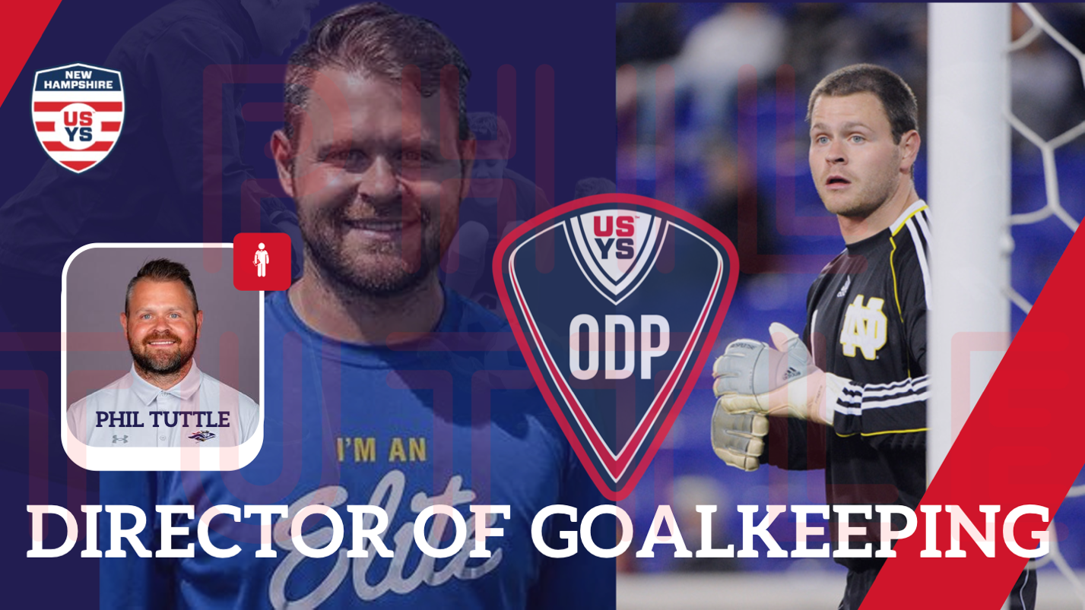
NH ODP STORE:
We have a 24/7/365 online store that is fully customizable with different logos (if an item shows a different logo, it can easily be changed in customized when you click on the item). You can also get additional kit gear, fan gear, etc. as well - the link is here:
NH ODP Team Store

Regional Events:
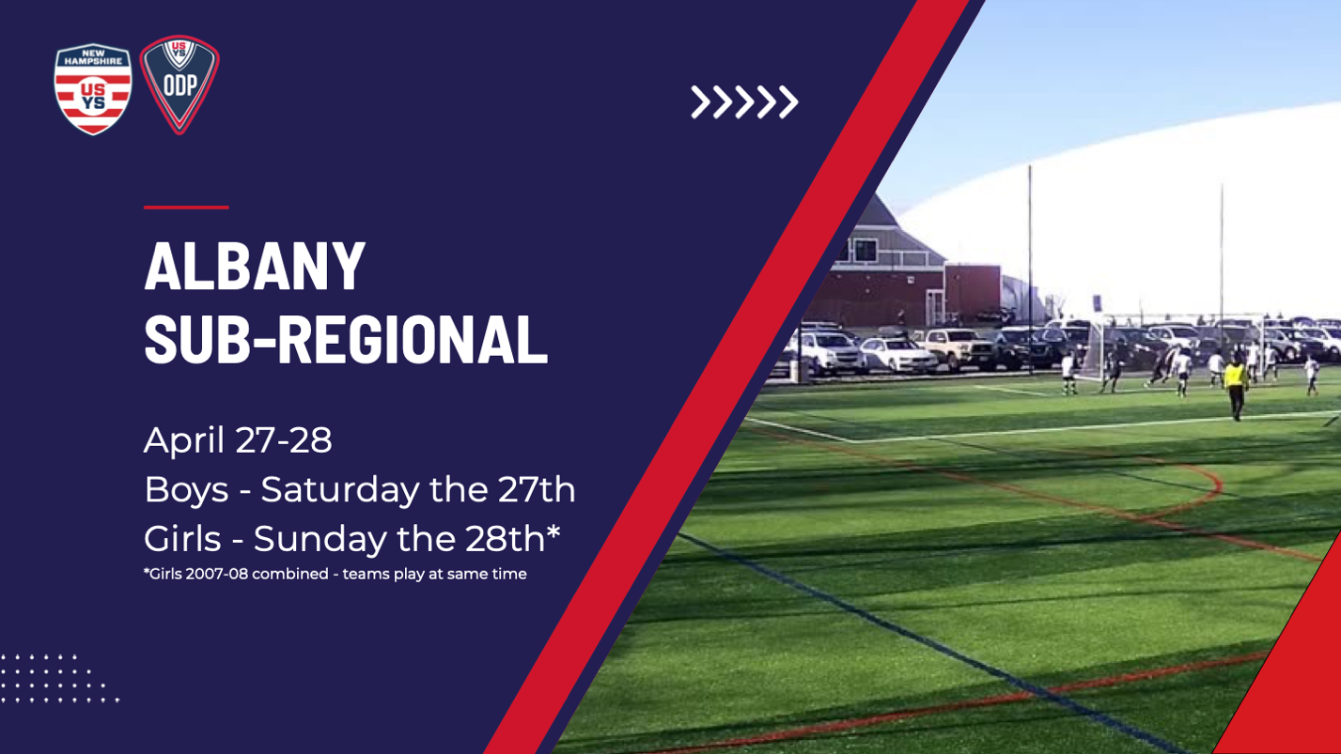
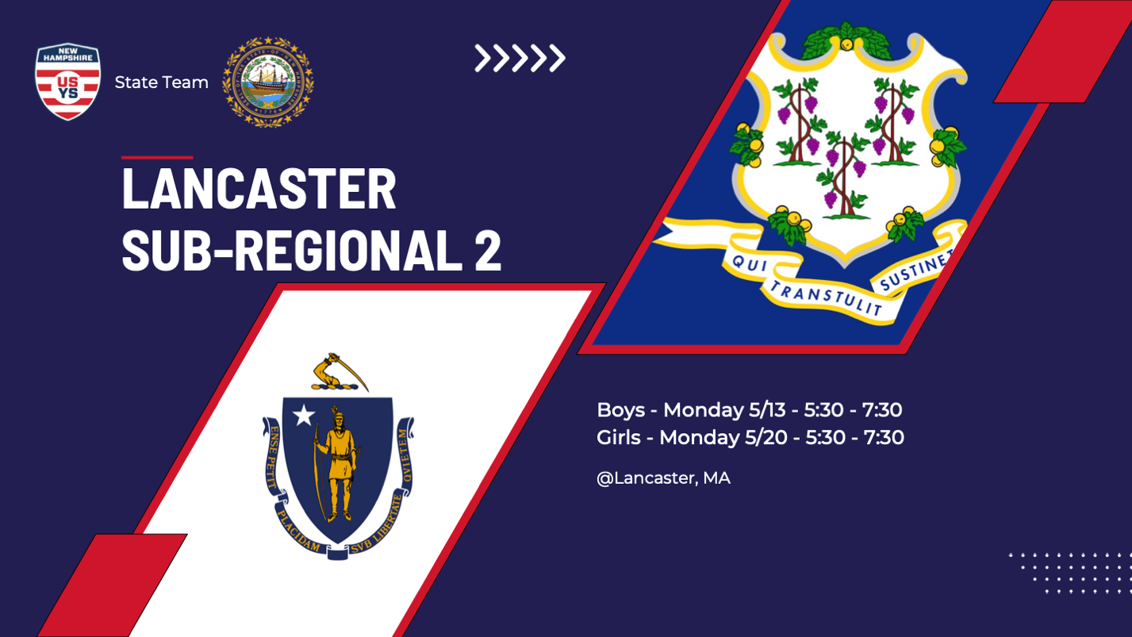
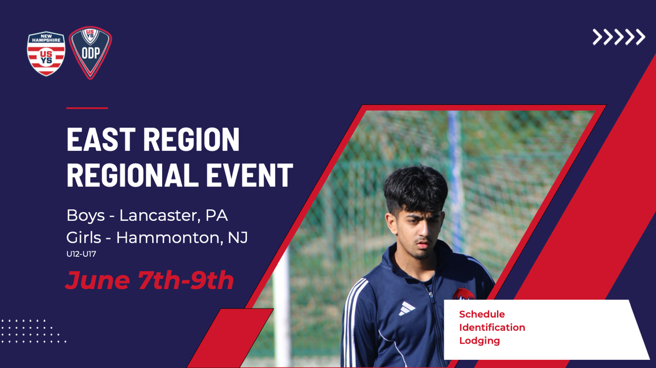
REGIONAL LODGING:
We have sent out links and details about the Boys Regional event in Pennsylvania - if you did not receive the details or have questions, please email us. The Girls event has a rolling hotel block hold - right now we have sent out links for U12-U14, as those close we will send out the U15-U17 detailas as sonn as we can (different travel partner providers with different systems / processes). Please reach out with any questions.
Albany has plenty of rooms, but we did not secure any blocks due to the timing of games, distance, and nature of people who may commute in and out same day. We suggest that within the team chat, those interested in staying overnight communicate with eachother to coordinate a place.
Boys Albany link for lodging: https://ttievent.com/eventmanager/onlineregistration.asp?D=d&EventCode=V13
Girls Albany link for lodging: https://ttievent.com/eventmanager/onlineregistration.asp?D=d&EventCode=M73
Thanks! We will be sharing more details specific to events and everything else as we get closer, but for the sake of further cognitive overload we will stop there for now.
See you on the pitch!
Ed & Joe
odpdirector@soccernh.org

